**Creating a custom role:**

Navigation: Navigator 🡪 Security console

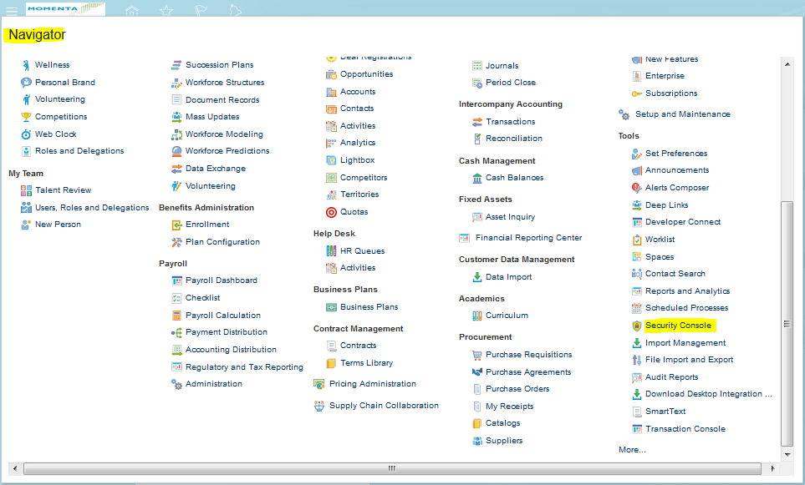

Click on ‘Create role’ button to create a new custom role as shown below.

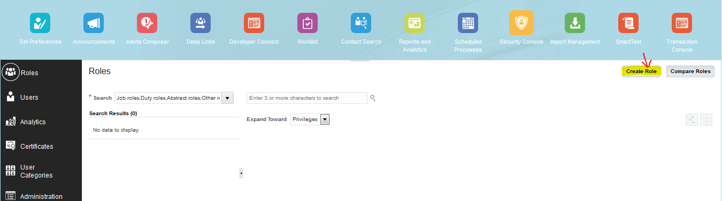

Enter the following details.

Role Name :MNTA GL MAINTAIN BALANCES CUBE CUSTOM

Role code: MNTA_GL_MAINTAIN_BALANCES_CUBE_CUSTOM

Role category: Common – Job Roles

Description: To access 'Publish Chart of Account Dimension Members and Hierarchies to Balances Cubes' job

Click on ‘Next’ button as shown below.

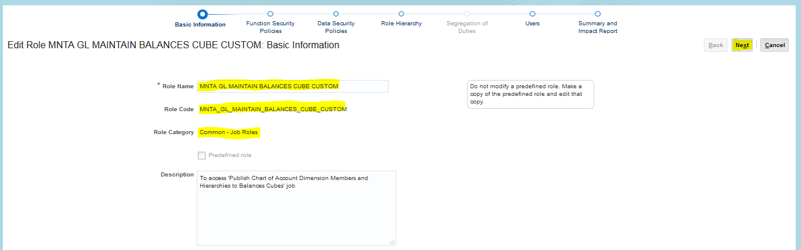

Click on ‘Add Function Security Policy’ button to add new Function Security Policy as shown below.

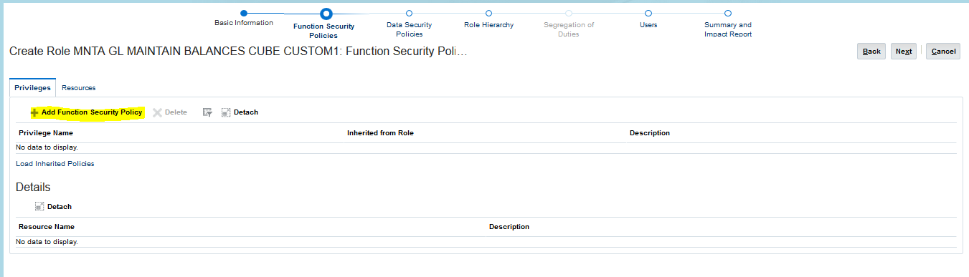

Search and select ‘Maintain Balances Cubes and Dimension Members’ then click on ‘Add Privilege to Role’ button as shown below.

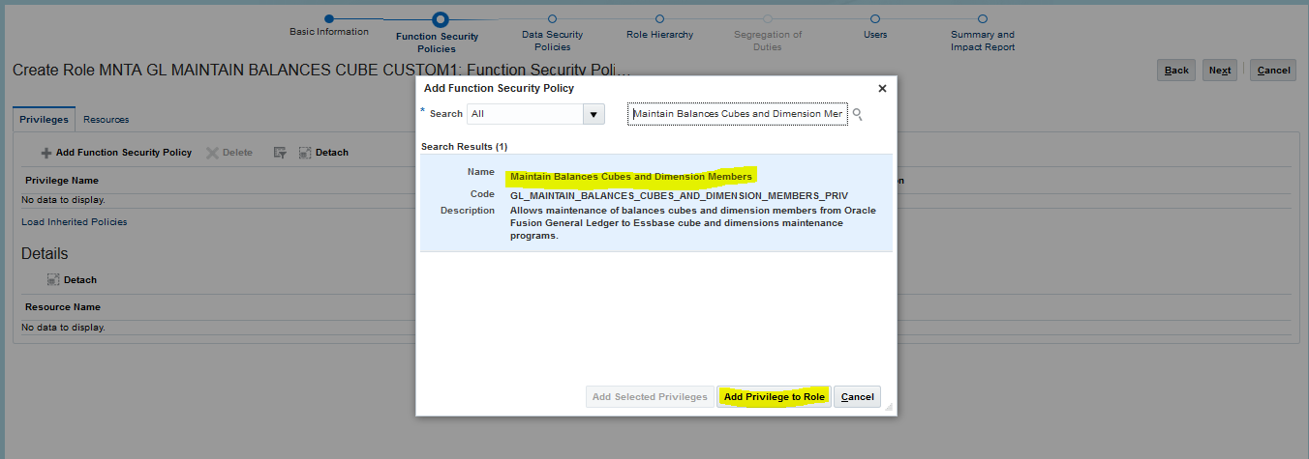

After adding privilege click on ‘Next’ button.

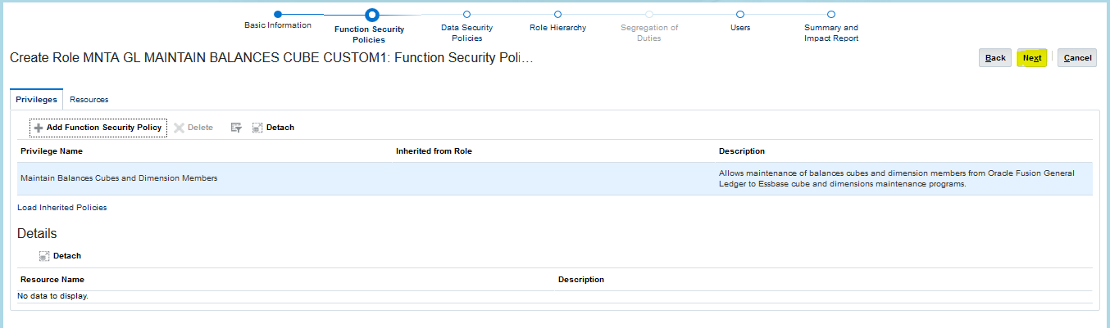

No need to add anything in Data security policies section. Click on ‘Next’ button.

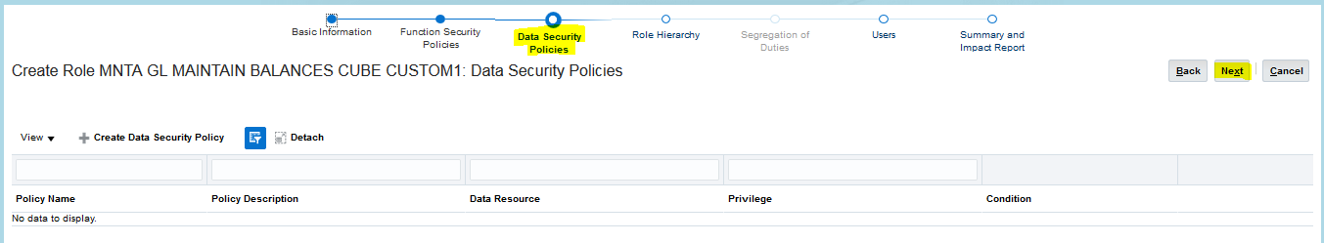

Click on ‘Summary and Impact report’ radio button .

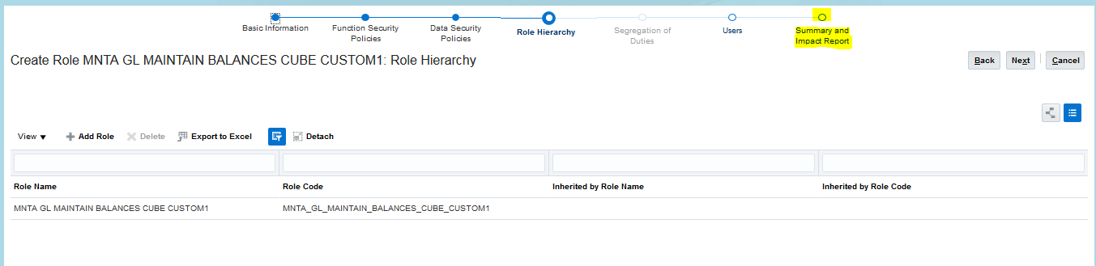

Click on ‘Save and Close’ button to save the new custom role.



New custom role was created.

**Creation of custom Lookup:**

**Note:**Create a custom lookup, if the Ess job 'Publish Chart of Account Dimension Members and Hierarchies to Balances Cubes status' end with an error.

Navigation: Setup and Maintenance 🡪 Manage standard Lookups

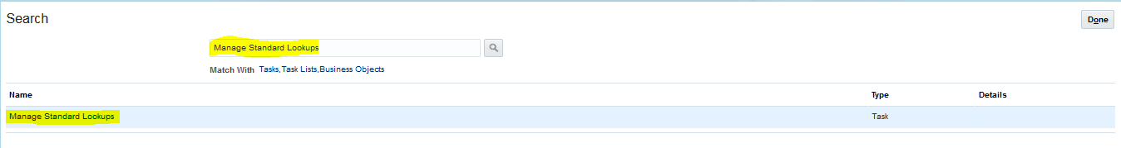

Click on ‘+’ icon to create a custom lookup as shown below.

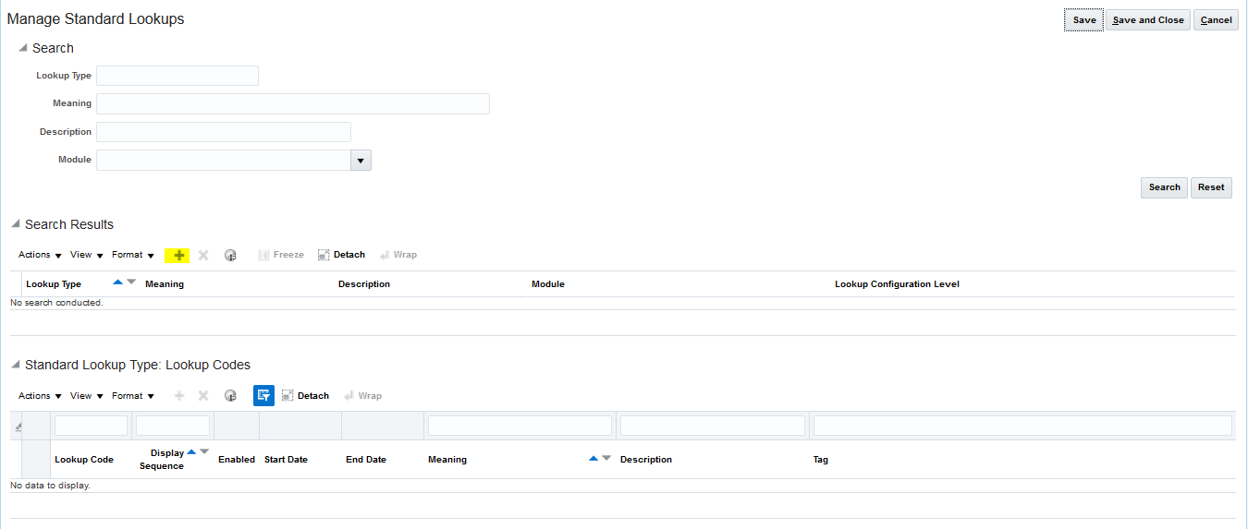

Enter the below details:

Lookup type: GL_SKIP_ESSBASE_VALUE_CHECK

Meaning: Skip validations

Module: General Ledger

Click on ‘Save’ button as shown below.

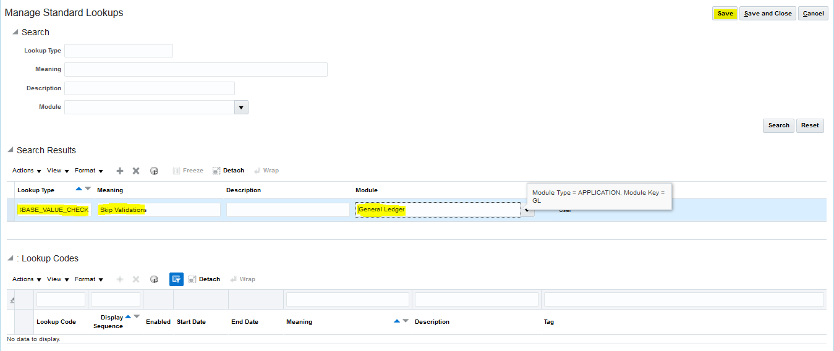

Now click on ‘+’ icon to add the Lookup code under GL_SKIP_ESSBASE_VALUE_CHECK: Lookup Codes section as show below.

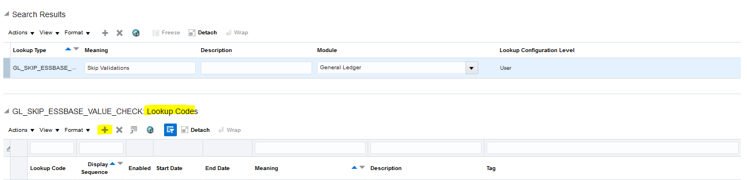

Enter the below details.

Lookup code: GEN

Display sequence: 1

Check the enabled check box.

Meaning: GEN

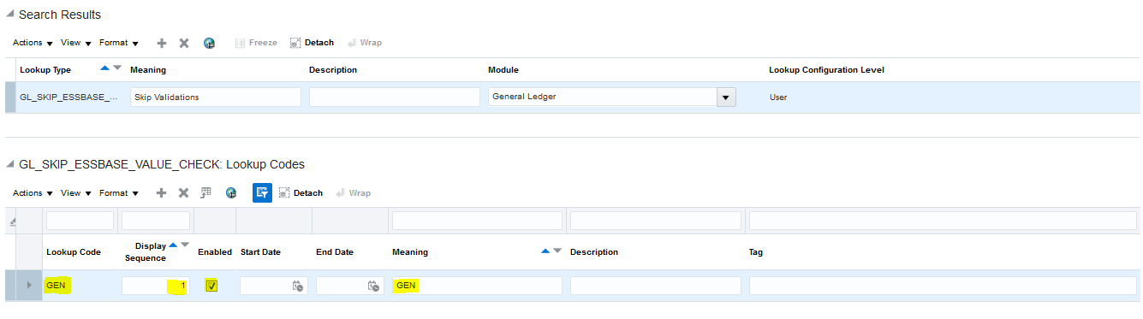

Save and close.