Create parameters as shown in the below screen shot

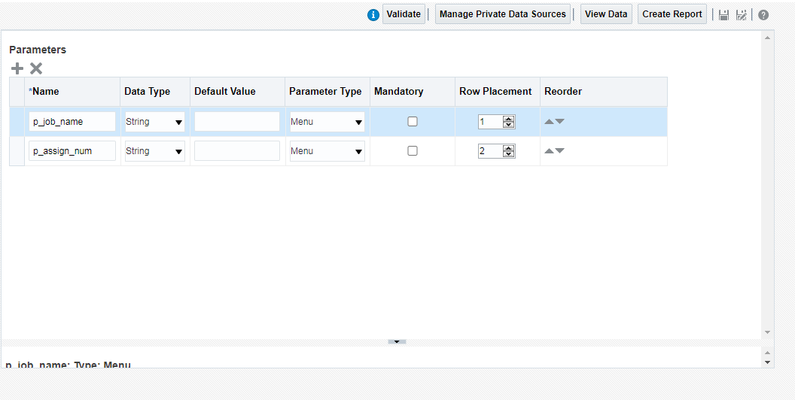

For Paramter p_assign_num LOV attached is Assignment_NUM_LOV and that LOV has SQL query

select assignment_number from PER_ALL_ASSIGNMENTS_F where job_id=(select job_id from PER_JOBS_F_VL where name=:p_job_name) and trunc(sysdate) between trunc(effective_start_date) and trunc(effective_end_date)

