The sequence is assigned in the completion date order using the GL date as the date criterion for determining the sequence to be used. The reporting sequence is assigned to both Subledger Accounting journal entries and General Ledger journal entries when the General Ledger period is closed.

Reporting Sequence Process Flow Diagram
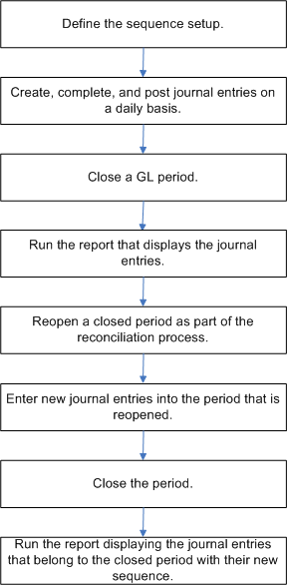

Below are the steps to create Reporting Sequencing

Navigate to your Project and Search for a Task Manage Accounting and Reporting Sequences

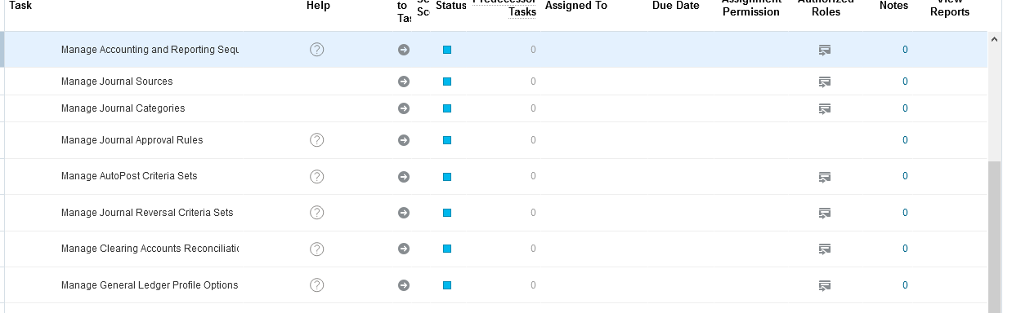
Apply and go to task

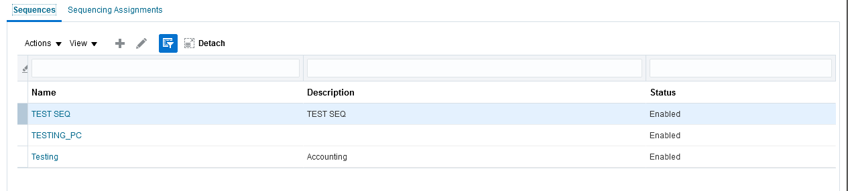
Enter the Details of the Sequence

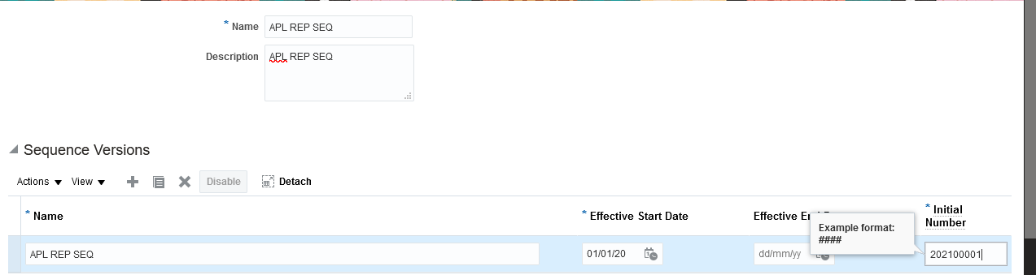
Navigate to Sequence Assignment

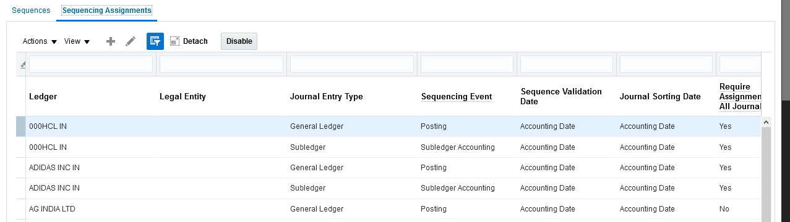

Enter the Ledger details
Journal Entry type you can choose as General ledger and Sequencing event as Period Close

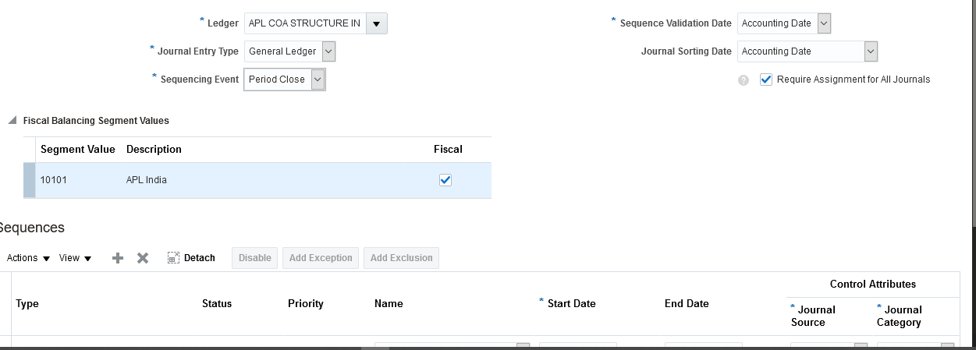
Enter journal and close the period
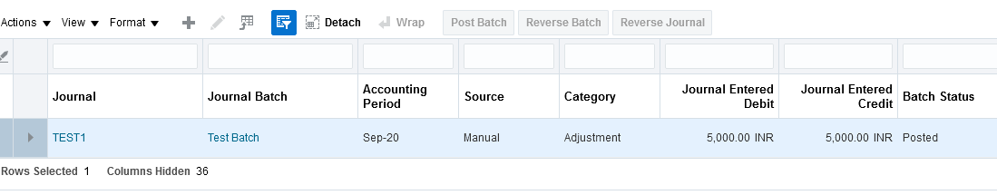

Reference: Docs.oracle .com

