# Journal Tax

There are many legal requirements for the enabling the journal tax, which will allow user to enter tax based on certain criteria.

Pre-reqs for creating Journal tax

1. Tax Regime
2. Taxes
3. Tax Status
4. Tax Jurisdiction
5. Tax rates
6. Tax Accounts
7. Tax Rules

Setups required for Journal tax

Navigate to Ledgers to enable tax at ledger level

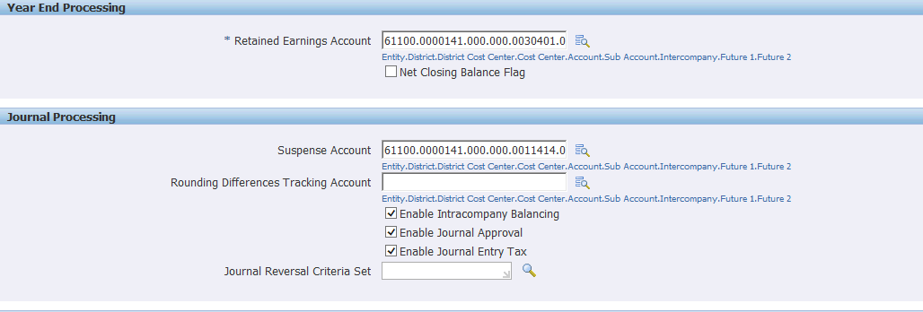

Define Tax options for ledger ->Setup->Tax->Tax options

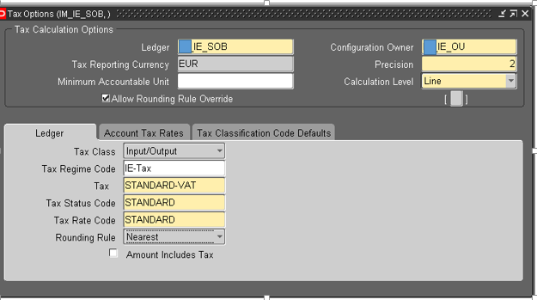

**Transaction Process in General Ledger:**

Navigation: General Ledger Super User ->Journal ->Enter

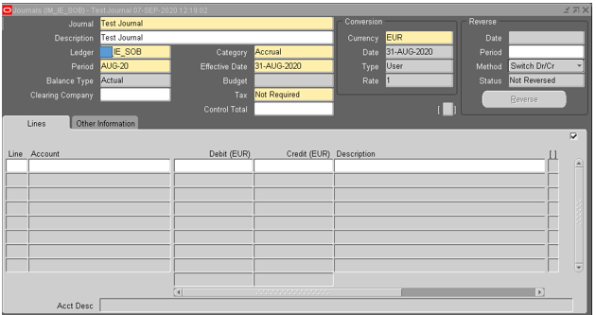

Set tax as required

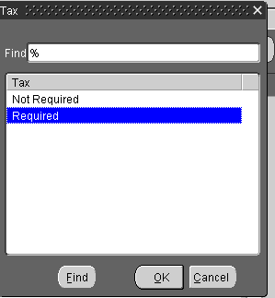

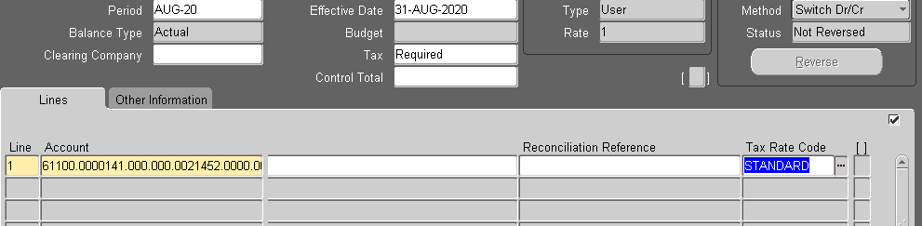

Click on TAX

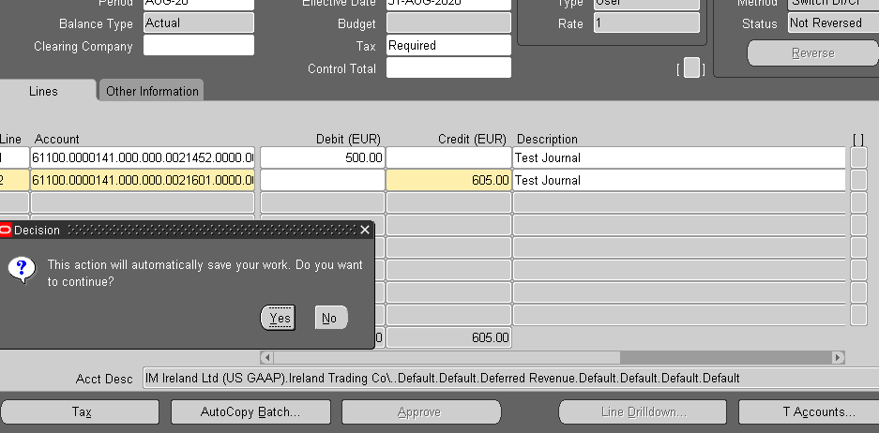

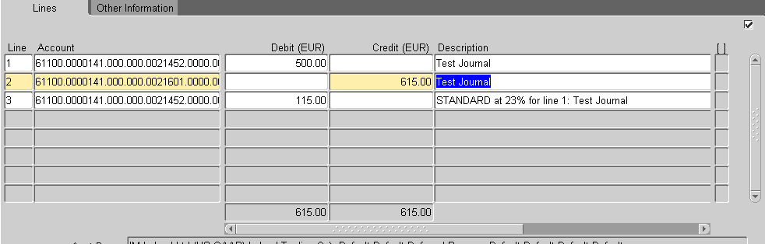

Save and Post the Journal