**Security rule setup in Fusion:**

Set up segment value security rules on value sets to control access to parent or detail segment values for chart of accounts segments, also called flexfield segments. Segment value security rules restrict data entry, online inquiry, and reporting.

Below are the steps to follow to implement security rule:

1. Enable security at value set level

2. Define conditions and policy

3. Submit

4. Deploy chart of accounts Structures

5. Logout and login back

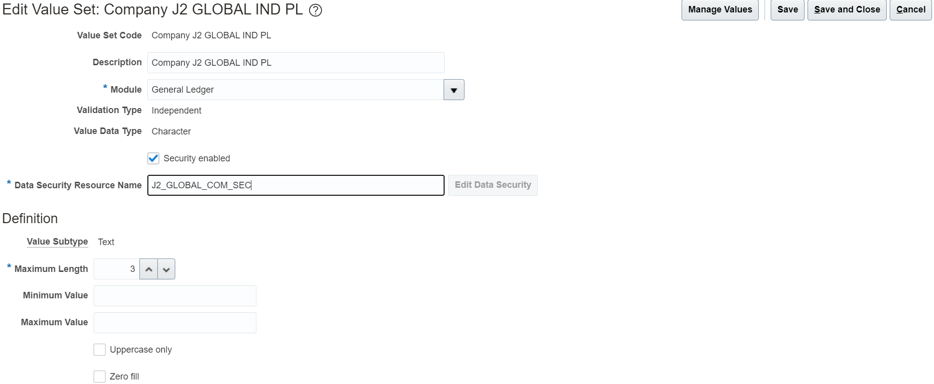

Click on save and then click on Edit Data security

Here we can add the condition and policy

Condition is equals to security rule definition in the EBS and Policy is equals to assign the security rule to the responsibilities in the EBS. Here we have the option to define security rule from the value set itself.

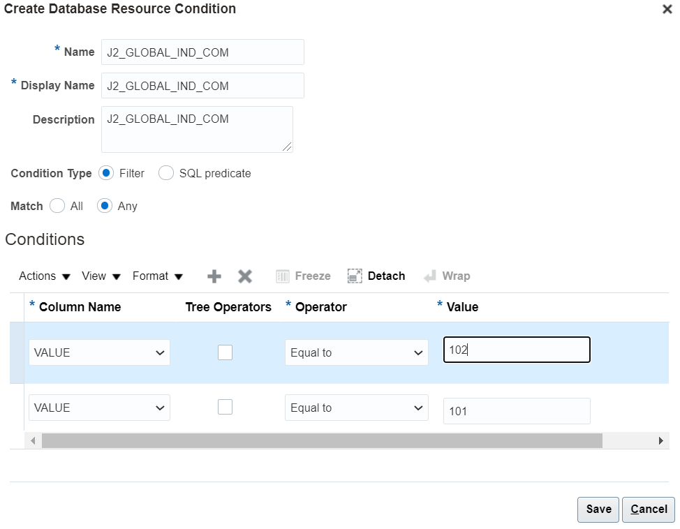

Here the requirement is to see the given 2 values when entering the transactions by using this particular role. To satisfy the condition we need to choose match option as ‘Any’.

Enter the values and click on save.

Create policy:

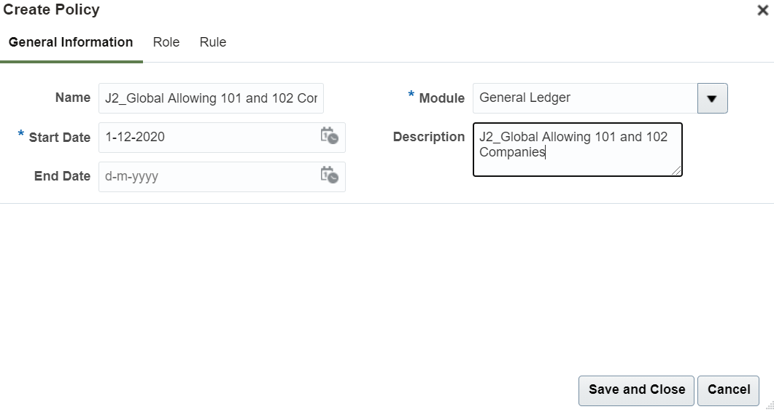

Go to Role tab

Select the role code for which role do you want to assign this security rule. Ex: General Accountant

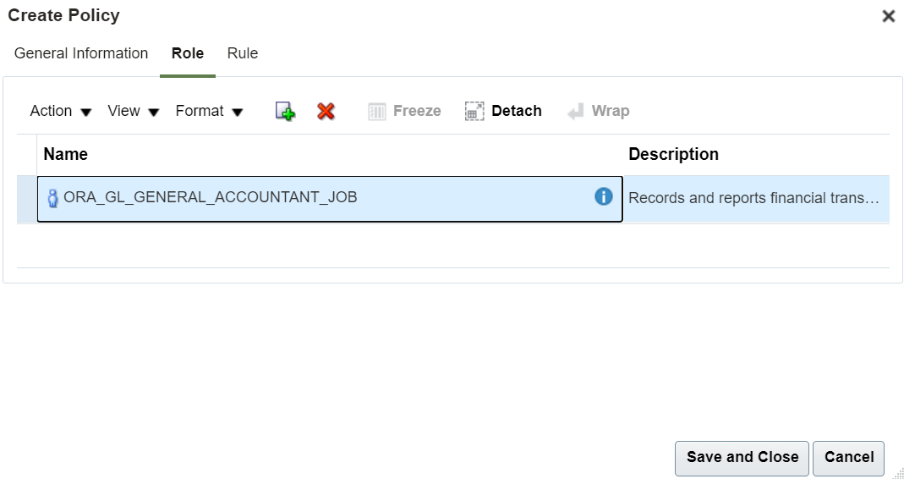

Go to Rule tab

Select the condition which we created for this security rule

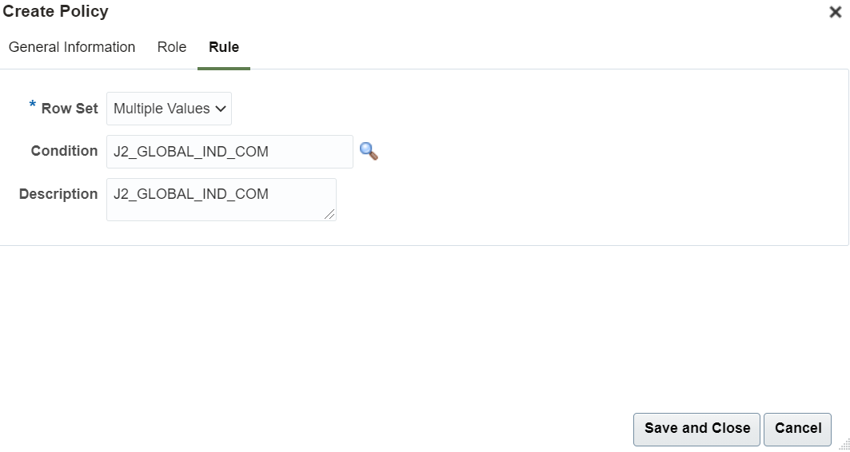

Click on save and close.

Click on save and click on Submit.

Deploy chart of accounts Structures:

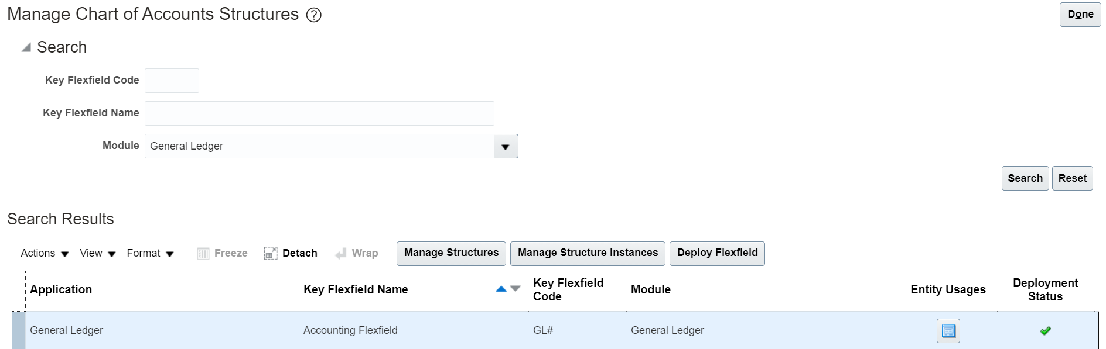

Now try to enter the Journals and check.

Now system only allow the included company segment values while entering the transactions.