AIM
MD.120 Create New Bank Account and Receipt Method,Document sequence
Author: Saikumar Paturi
Creation Date: 18-SEP-2020
Last Updated: 18-SEP-2020
Document Ref: <>
Target Instance FINS01
Associated Incident/Request: TASK0502909
Associated Change Request :
Version: 1.0

Approvals:

<Approver 1>

<Approver 2>

Copy Number

Date
Author
Version Change Reference

Document Control

Change Record

18-SEP-2020 | Saikumar Paturi | 1.0 | No previous document

Reviewers

Name Position

Distribution

Copy Name Location
No.
1 | Library Master | Project Library
2 |  | Project Manager
3
4

Note To Holders:

If you receive an electronic copy of this document and print it out, please write your name on the equivalent of the cover page, for document control purposes.

If you receive a hard copy of this document, please write your name on the front cover, for document control purposes.

Contents

Document Control ii
Introduction 4
Purpose 4
Audience 4
Installation Pre-Requisites and Assumptions- 4
Back-out Plan- 4
Steps- 4
Open and Closed Issues for this Deliverable 7
Open Issues 7
Closed Issues 7

Introduction
This document target is Create bank account and reciept method in UAT Instance

Purpose
User have transactions to be handled

Audience
Oracle Receivables and oracle CM

Installation Pre-Requisites and Assumptions-
To be tested in FINT01and approved by business to move to FINS01

Back-out Plan-
Based on business request the changes can be endated .

STEP 1 : To be executed by DBA team

Responsibility – System administrator

Navigation – Profile – System

>Enable Responsibility check box

> Responsibility name : IM GR CM Superuser

>Profile name : CE: Disable Bank Validations

>System Profile values window will display

Enter yes at responsibility level as per screenshot and click on save

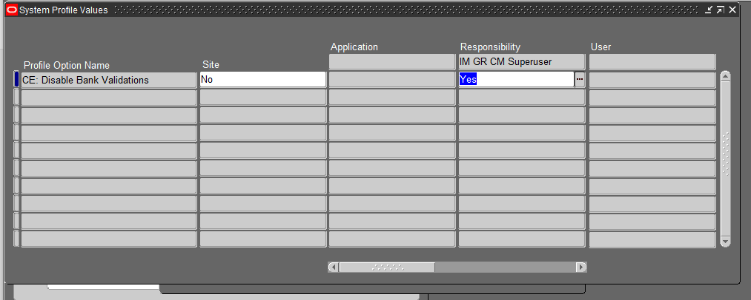

Steps-2: Create Bank Account(As per excel sheet)

Responsibility – IM GR CM Super User

Navigation : Setup – Banks - Banks

Step 3: Create Receipt Method(As per excel sheet)

Responsibility : IM GR AR AMS Support

Navigation : Receipts – Receipt classses

STEP 4: To be executed my DBA Team

Responsibility : System administrator

Navigation : Application - Sequential Numbering - Categories

Application | Code | Name | Description | Table Name
Cash Management | Iron Mountain Hellas 3 | Iron Mountain Hellas 3 | Iron Mountain Hellas 3 | CE_STATEMENT_HEADERS

Navigation : Application – sequential numbering - Assign

>>Click on Document Tab

Application | Category | Ledger | Method
Receivables | GR Manual Receipt_8712 | IM Greece Ledger | Null

>>Click on Assignments tab,

Application | Category | Start Date | End Date
Receivables | GR Manual Receipt_8712 | 1-Jan-20 | 31-Dec-20

Sequence
IRON_GR_AR_RECEIPT_2020

STEP 5: To be executed my DBA Team

Responsibility : System administrator

Navigation : Application - Sequential Numbering - Assign

>>Click on Document Tab

Application | Category | Ledger | Method
Cash Management | Iron Mountain Hellas 3 | IM Greece Ledger | Null

>>Click on Assignments Tab

Application | Category | Start Date | End date
Cash Management | Iron Mountain Hellas 3 | 1-Jan-20 | 31-Dec-20

Sequence
IRON_GR_CM_BNK_STMT_2020

Step 6 : To be executed my DBA Team

Responsibility – System administrator

Navigation – Profile – System

>Enable Responsibility check box

> Responsibility name : IM GR CM Superuser

>Profile name : CE: Disable Bank Validations

>System Profile values window will display

Leave Blank at responsibility level as per screenshot and click on save

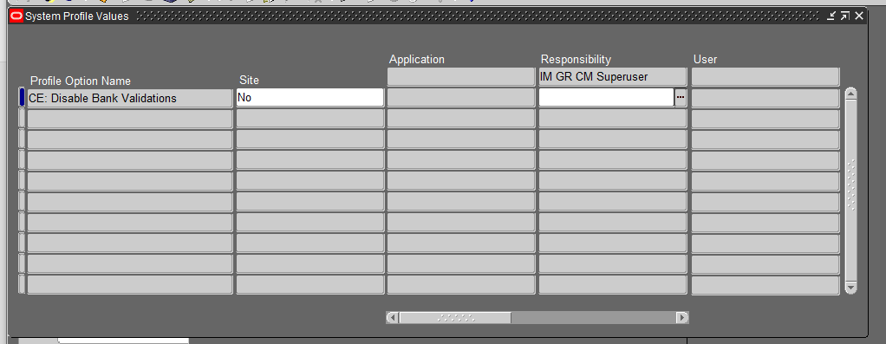

Open and Closed Issues for this Deliverable

Open Issues

ID | Issue | Resolution | Responsibil ity | Target Date | Impact Date

Closed Issues

ID | Issue | Resolution | Responsibil ity | Target Date | Impact Date

