How To enable DFF in Bank Account Transfer.
1.Enable the DFF
2.Create trigger for that DFF

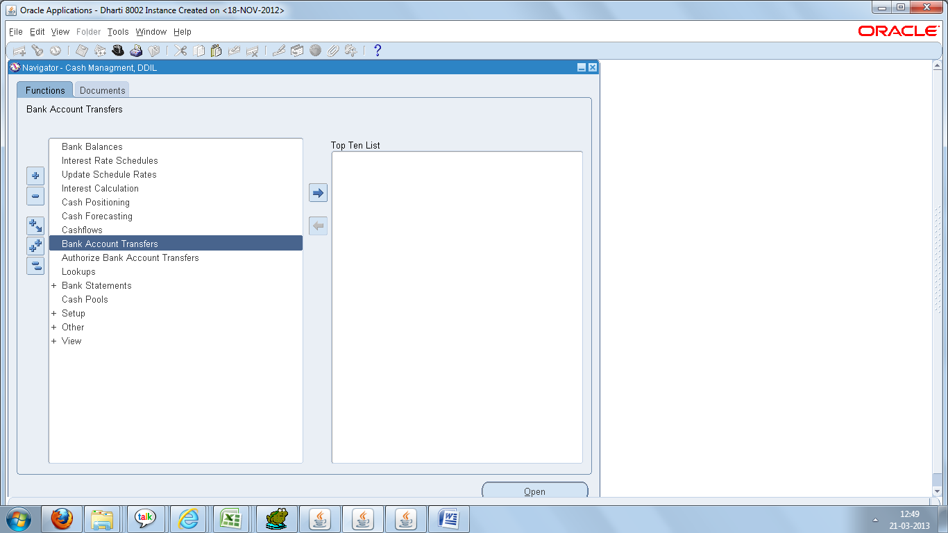

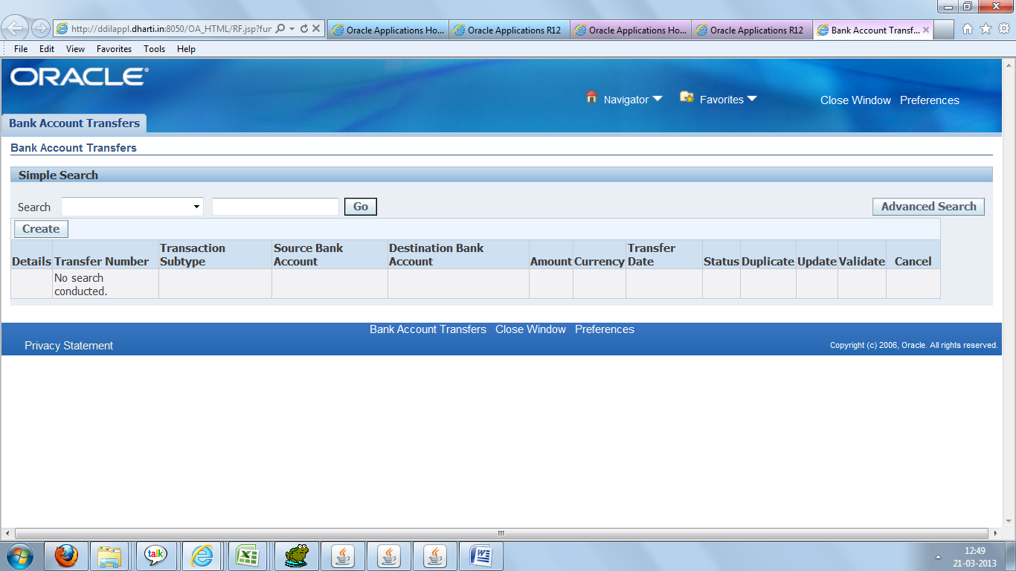

Click on GO button

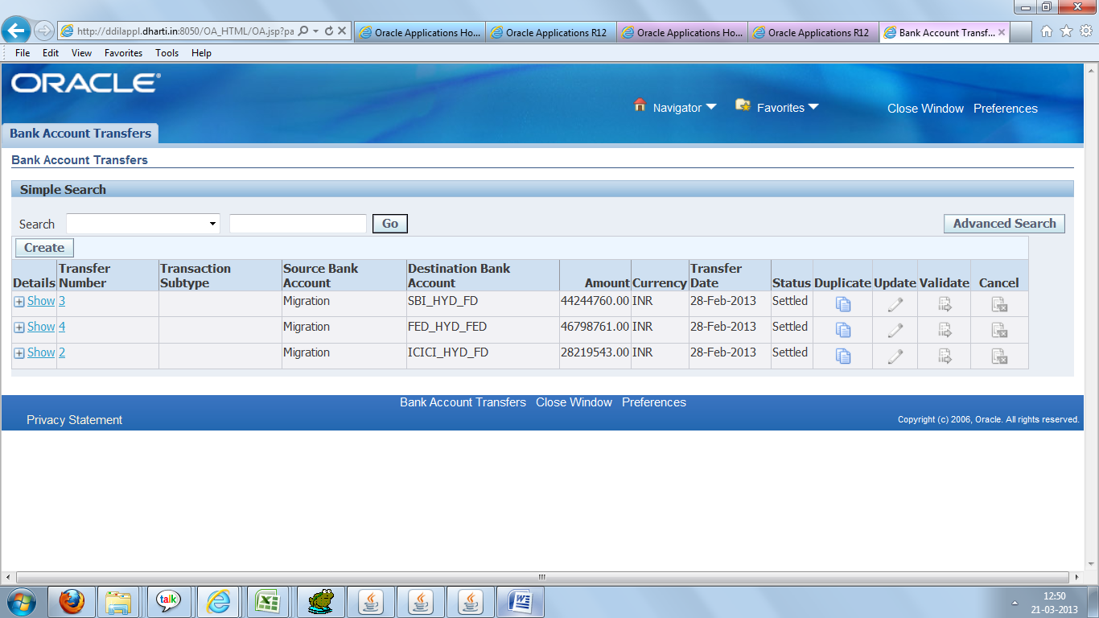

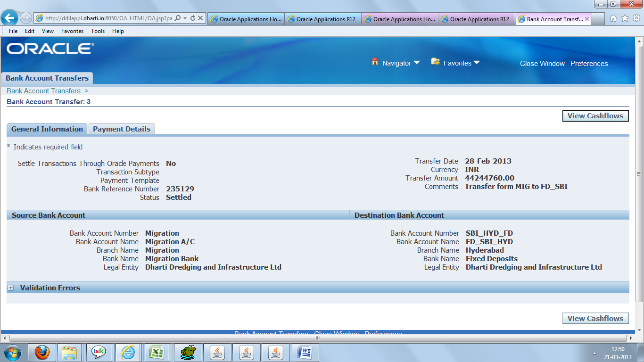

Click on Payment Details

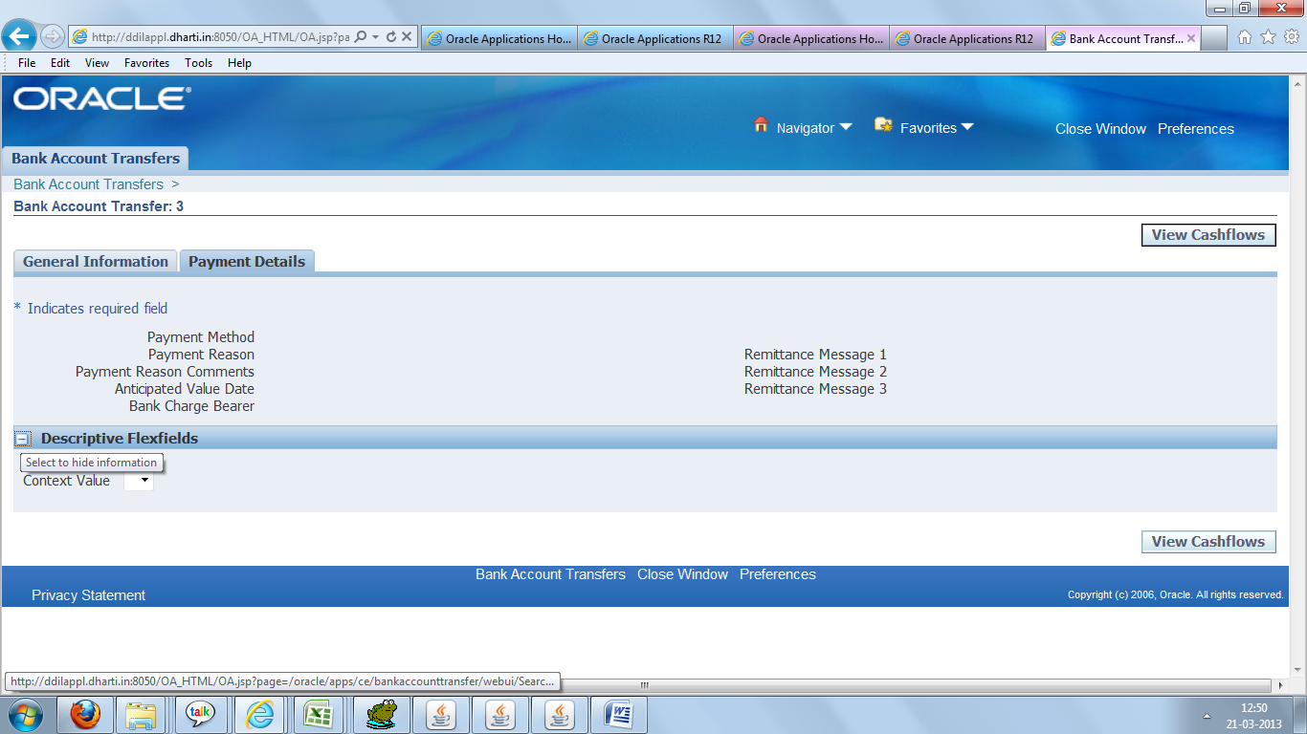

1)Here we need to Enable DFF.

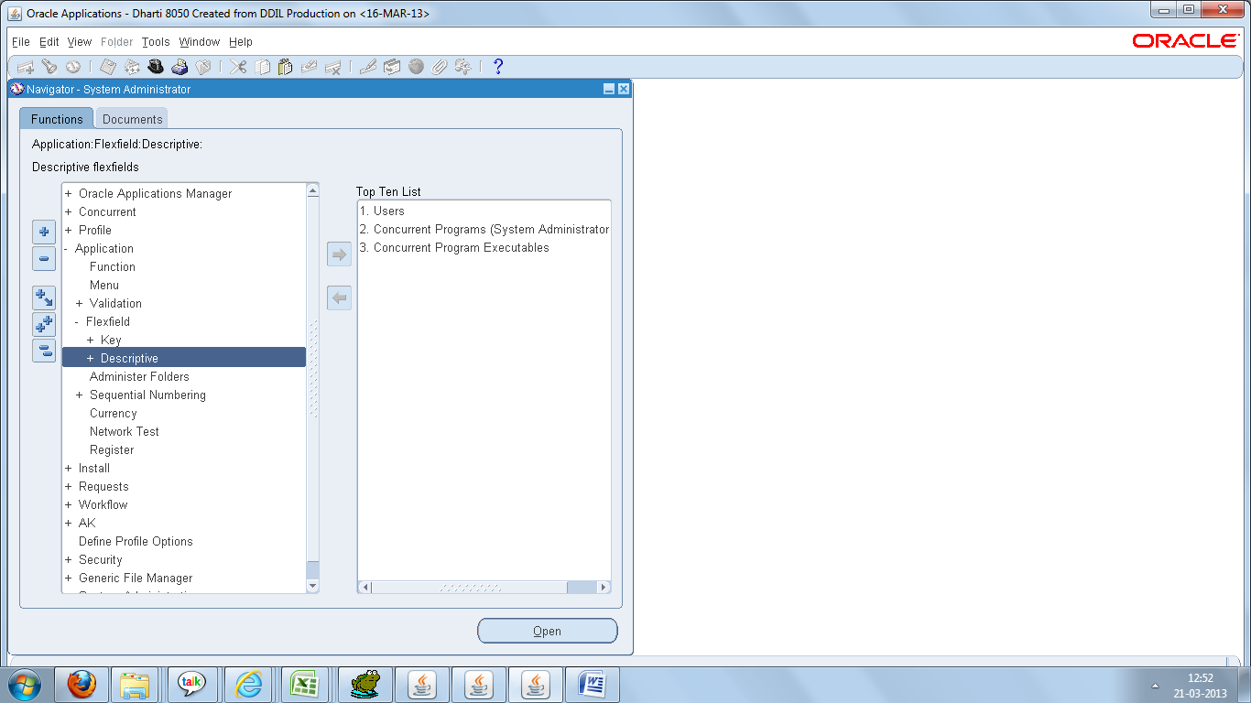

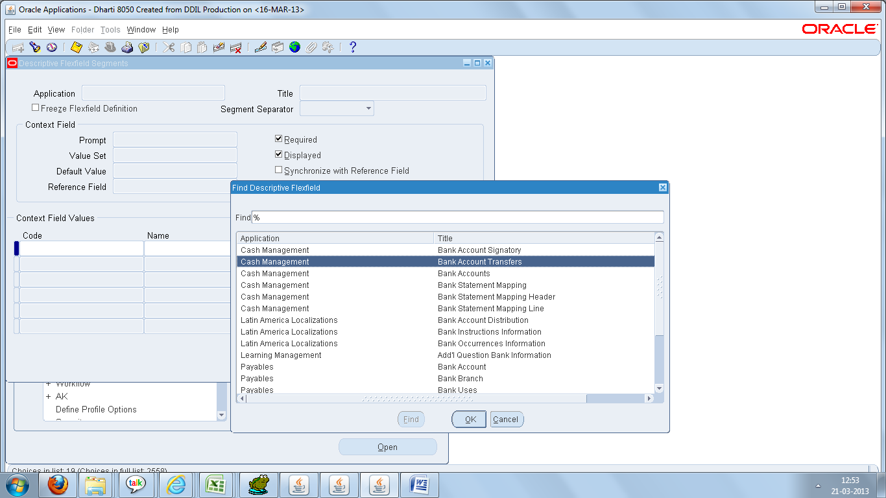

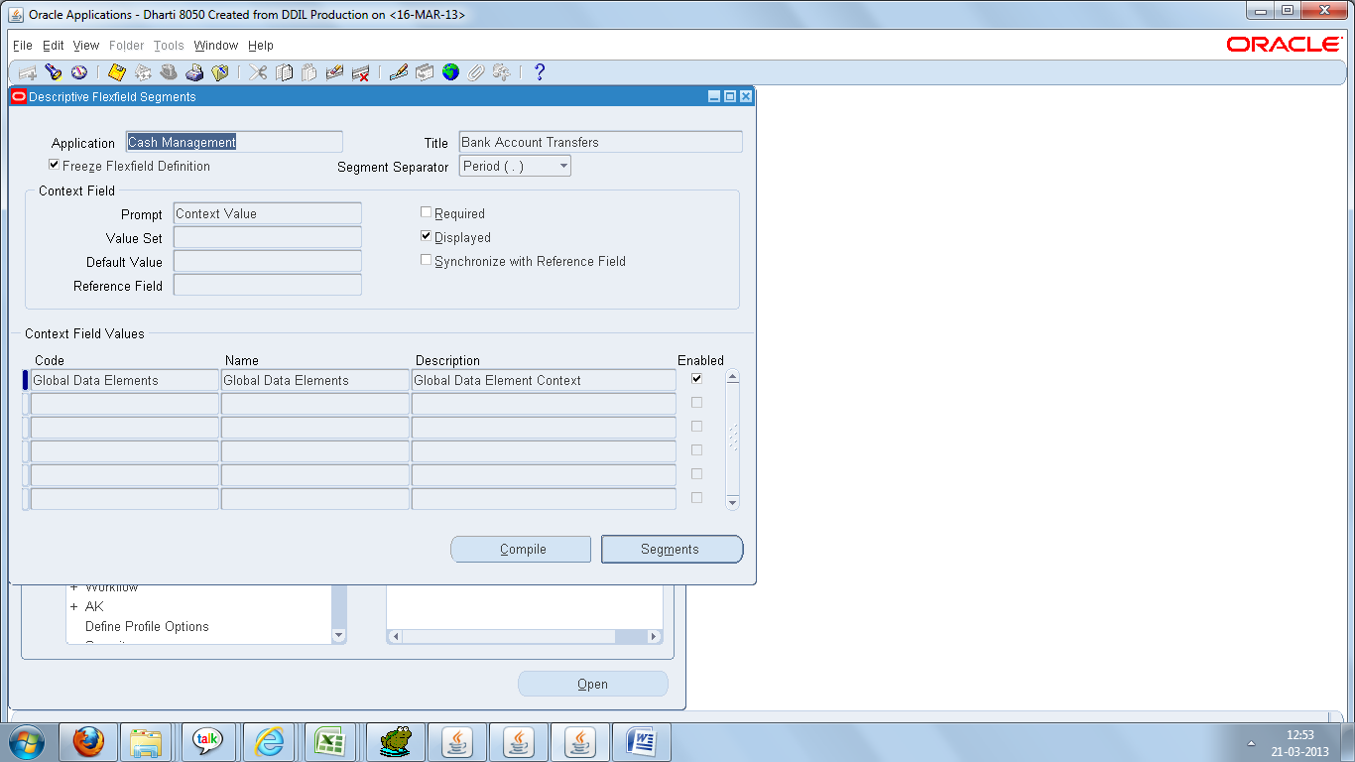

we need unfreeze freeze Flexfield Definitions first and then add Segment
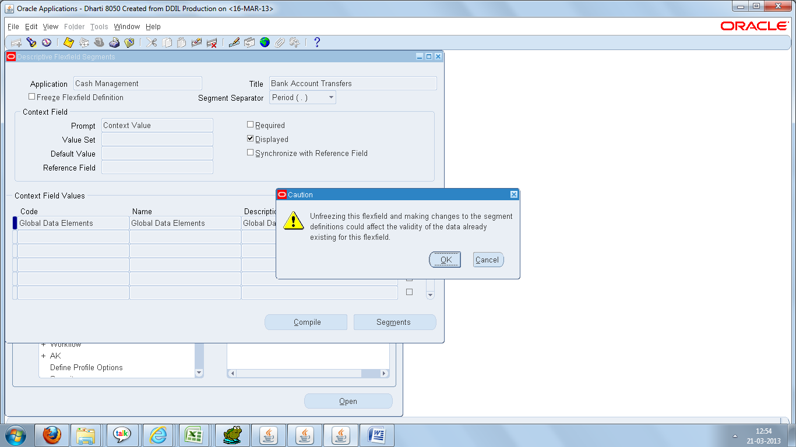

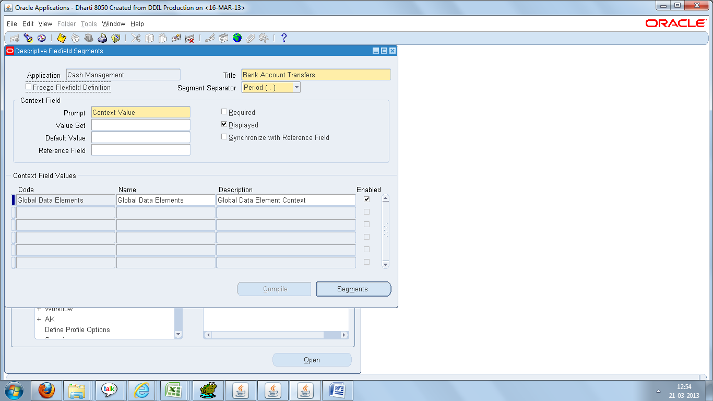

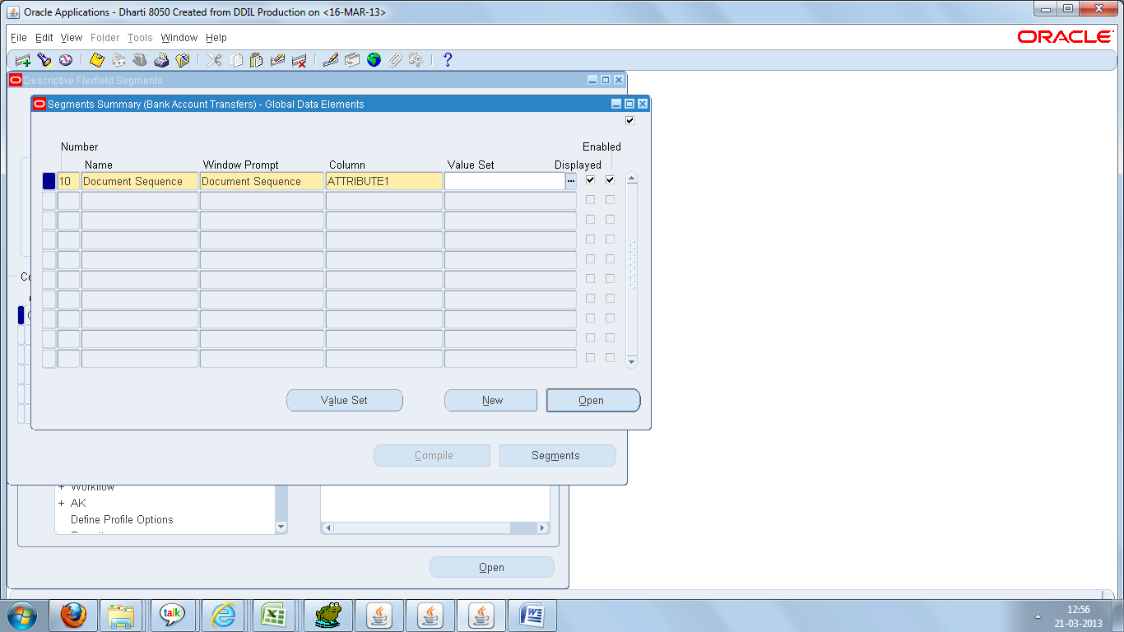

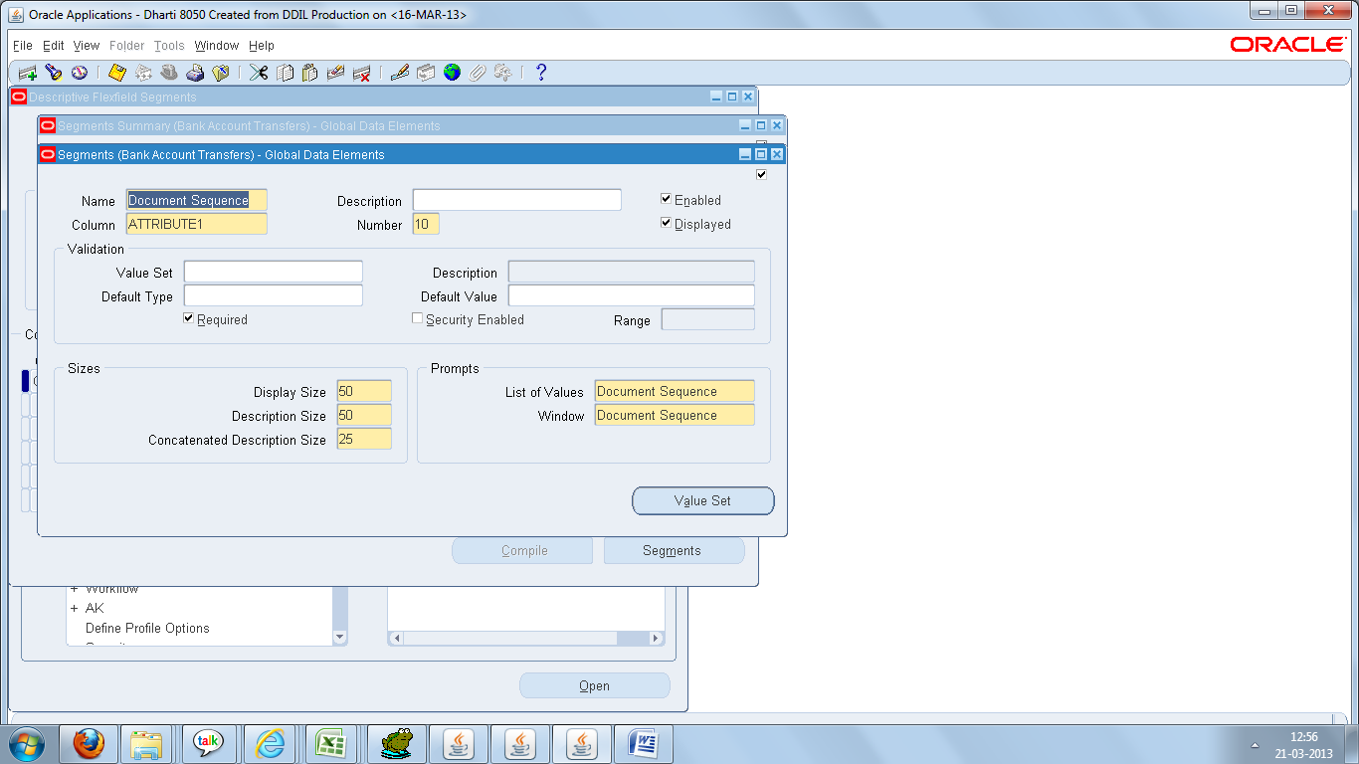
Save,freeze and compile.
Now see the page

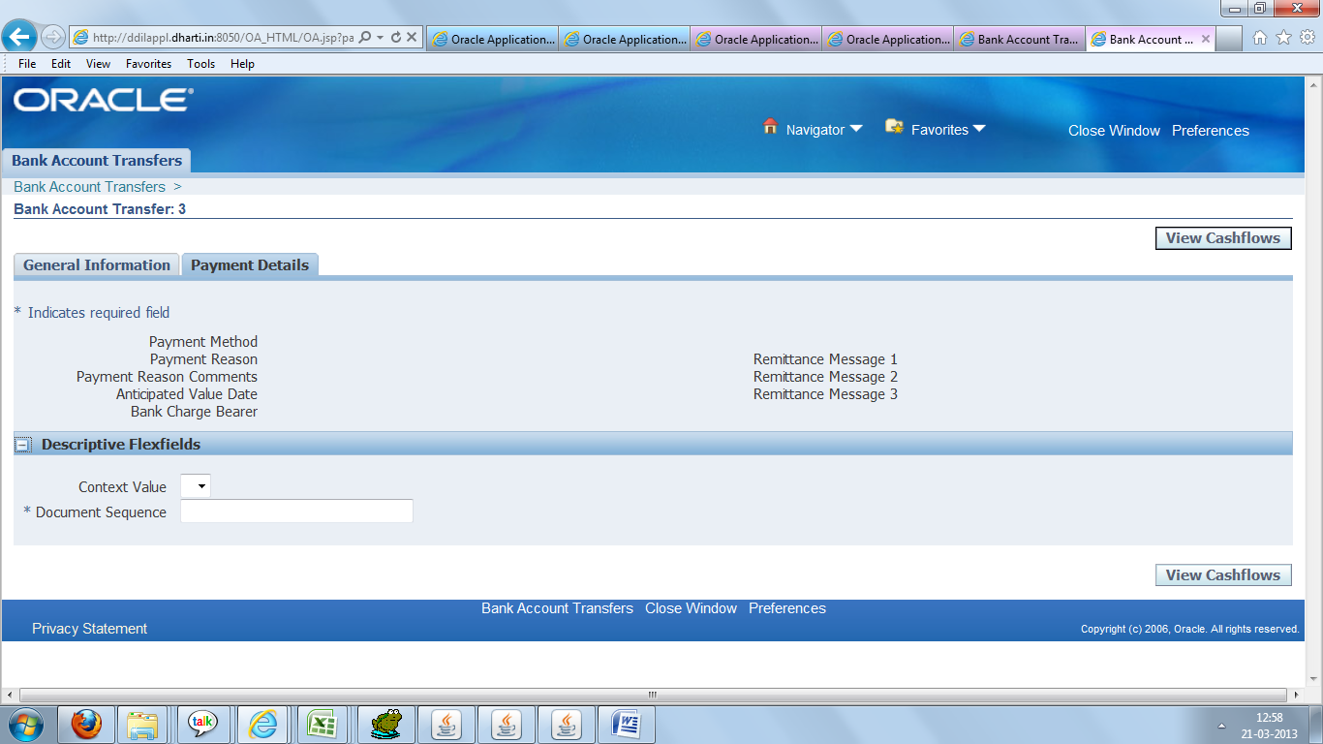

We need add Document Sequence Number into Attribute1 coulmn in CE_PAYMENT_TRANSACTIONS
Table.

CREATE OR REPLACE TRIGGER APPS.XX_BANK_AC_TRN_SEQ_NO_GEN
BEFORE INSERT
ON CE_PAYMENT_TRANSACTIONS
FOR EACH ROW
BEGIN
SELECT XX_BANK_AC_TRN_SEQ_NO.NEXTVAL INTO :New.Attribute1 FROM DUAL;
EXCEPTION
WHEN others then null;
END;

/

CREATE SEQUENCE APPS.XX_BANK_AC_TRN_SEQ_NO
START WITH 100000001
MAXVALUE 999999999999999999999999999
MINVALUE 1
NOCYCLE
NOCACHE
NOORDER;

